**Team- Abhik**

Project 2 Study Task

Summary Report step-6 (Market Segmentation Analysis - McDonald case study)

*By Yash Dawande*

Summary Report:

Step 6: Profiling Segments

The core of the segmentation analysis is complete: market segments have been extracted. Now we need to understand what the four-segment k-means solution means. The first step in this direction is to create a segment profile plot. The segment profile plot makes it easy to see key characteristics of each market segment. It also highlights differences between segments. To ensure the plot is easy to interpret, similar attributes should be positioned close to one another. We achieve this by calculating a hierarchical cluster analysis. Hierarchical cluster analysis used on attributes (rather than consumers) identifies – attribute by attribute – the most similar ones.

Written code for profile segments:

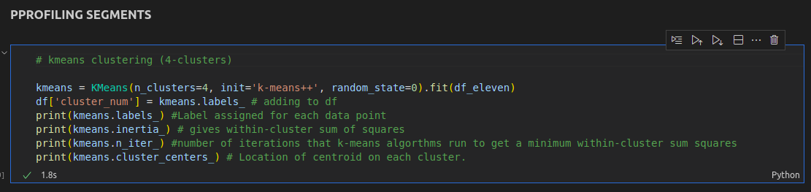

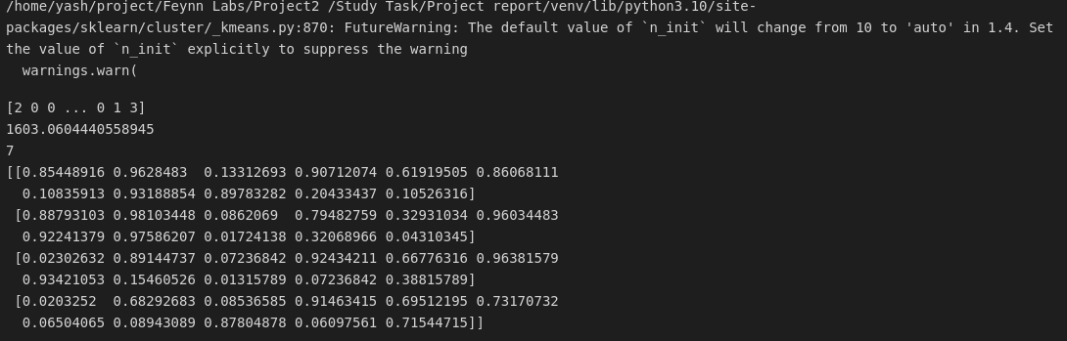

The visualization that can help managers grasp the essence of market segments is the segment separation plot shown in Fig. The segment separation plot can be customized with additional arguments. We choose not to plot the hulls around the segments (hull = FALSE), to omit the neighborhood graph (simlines = FALSE), and to label both axes (xlab, ylab):

Creating visualization:

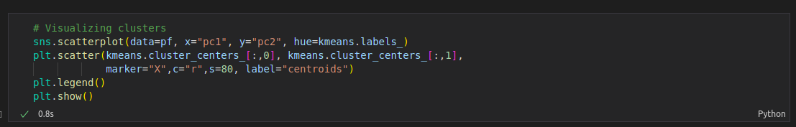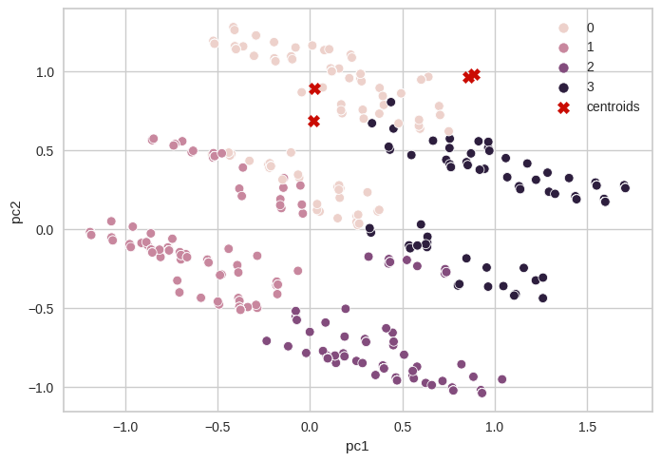

As can be seen, segments 1 and 4 both view McDonald’s as cheap, with members of segment 4 holding – in addition – some positive beliefs and members of segment 1 associating McDonald’s primarily with negative attributes. At the other end of the price spectrum, segments 2 and 3 agree that McDonald’s is not cheap but disagree on other features with segment 2 holding a less flattering view than members of segment 3.

At the end of Step 6 McDonald’s we have a good understanding of the nature of the four market segments in view of the information that was used to create these segments.